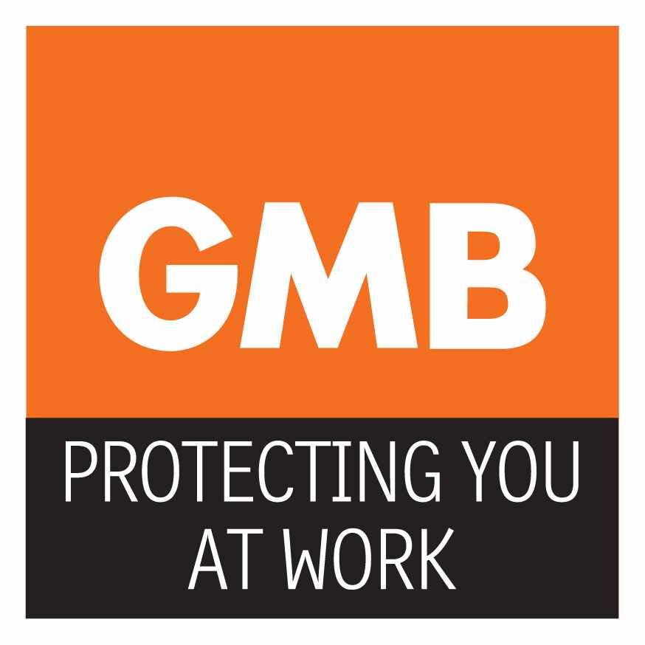
GMB MEMBERSHIP SURVEY – HOLIDAY PAY

Dear Colleague May 2016

We are currently updating our records to ensure that we have the necessary information on your workplace details; this is because we are looking into whether the Royal Borough of Greenwich may have calculated holiday pay wrong and we therefore require some details from you to help investigate this. In particular please let us know the number of hours your contract says you should do. We also need to know if you have been asked to work more than your contracted hours.

Given the above, could you please complete the form below and return it in the envelope provided. We sincerely appreciate any assistance you can offer us in supplying us with the relevant requested information.

Please email the information to this address:
steve.oakes@royalgreenwich.gov.uk

Name: …………………………………………………………………………….

Membership Number: …………………………………………………………..

Address: ………………………………………………………………………….

……………………………………………………………………………………..

Tel Numbers: mobile: ………………………… Home………………………..

E-mail address: …………………………………………………………….……

Name of Employer …………………………………………………….………..
Name of Workplace………………………………………………………………

Address: ……………………………………………………………………;…….

………………………………………………………………………………………

Job Title …………………………………………………………………………..

How many hours a week are you contracted to do?.....................................

How many hours do you actually work?........................................................

How many weeks per year are your contracted to work?.............................
3 Parkview Road, Welling, Kent, DA16 1SY, Tel: 020 8303 3407

